Wireless Security

Wireless Physical Layer Technology

Weight: 1.15% Marks:  /44

Student Name: Coleton Sanheim

Student ID: 000862545 Date: 2022-02-04

# Introduction

In this lab, you will focus on wireless physical layer technology.

Lab activities in this course will be marked in class. You must bring this document to every lab in the module. Each activity must be completed and then marked by the instructor before you move on to the next. To avoid a mark of zero for an activity, contact the instructor immediately if you cannot complete the activity for any reason, or if the activity was left unmarked by the instructor.

# Equipment

* WiFi Inspector, WiFi Analyzer or NetSurveyor
* Any other tools that provide RSSI or dBm measurements of WiFi signals
* Wireshark with Npcap

# Lab Setup

Before you begin the lab activities, perform the steps below to set up your computer.

1. Set up a Windows workstation or Android/iOS device with the following parameters:

* Wireless network adapter
* WiFi tool installed

1. Set up an additional Windows/Linux workstation or Android/iOS device with the following parameters:

* Wireless Network Adapter
* WiFi Inspector installed
* Latest version of Wireshark with Npcap

# Activity 3.1: Verifying Setup of the WiFi Identified Radiator (IdRad)

1. Identify the radiator (IdRad) and complete the setup. (2 points)

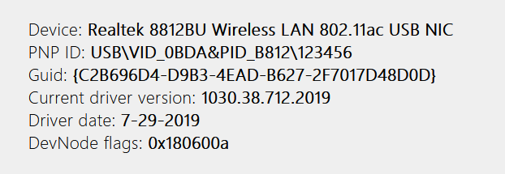

1. Verify that the software is working. (2 points)

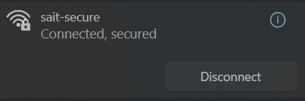

**Instructor sign-off:** __________________ (5 points)

# Activity 3.2: Identifying the Location of the IdRad

1. Using your chosen network measurement tool, record the RSSI or dBm and the channel of IdRad when standing 10 m away:

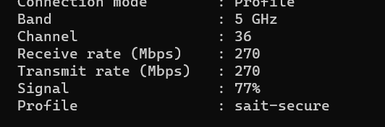

-dBm = -61.5

_________________________ (2 points)

1. Complete WiFi performance testing:____________________ (2 points)

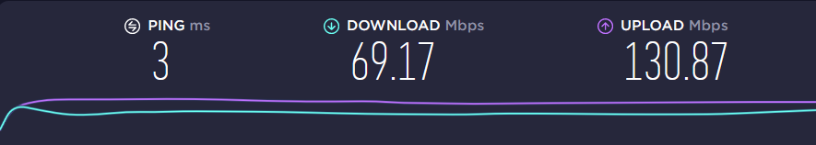

1. Record the orientation of your device, using the image below for reference: ___________________(2 points)

|  |
| --- |
|  |

**Instructor sign-off:** __________________ (5 points)

# Activity 3.3: Changing the Device Orientation

1. Change the orientation of your device, and then record its new position: ___________________.

I rotated it 90 degrees around the y (positive gamma) axis

Record the RSSI or dBm: ___________ (2 points)

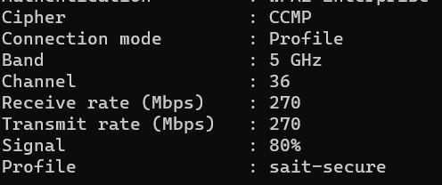

-dBm = -60

1. Complete WiFi performance testing:____________________ (2 points)

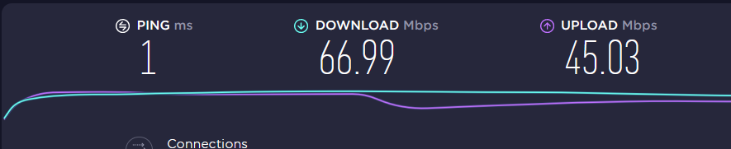

1. Change the orientation of your device, and then record its new position: ___________________.

I rotated it 90 degrees around the x (positive beta) axis.

Record the RSSI or dBm: ___________ (2 points)

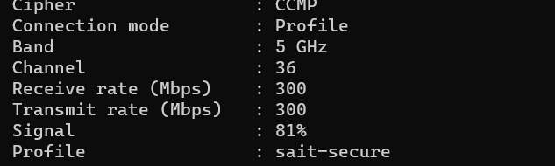

-dBm = -38.5

1. Complete WiFi performance testing:____________________ (2 points)

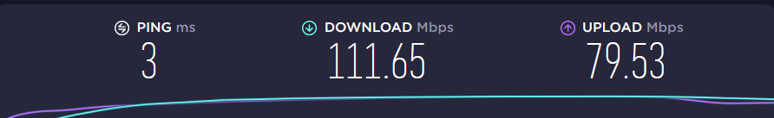

1. Change the orientation of your device, and then record its new position: ___________________.

I rotated 90 degrees around the z (negative alpha) axis

Record the RSSI or dBm: ___________ (2 points)

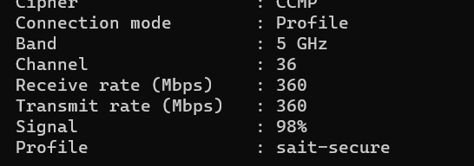

-dBm = -51

1. Complete WiFi performance testing:____________________ (2 points)



**Instructor sign-off:** __________________ (5 points)

# Activity 3.4: Summary Analysis

Write a short paragraph summarizing your analysis of the data you recorded. (2 points)

___Rotating around the z axis (negative alpha) resluted in the best signal strength. Rotating around the y axis (positive gamma) resulted in the worst signal strength. However most of the changes were minor and could just be as a result of other factors, the only factor that seemed to matter was how close the adapter was to the radiator. ____________________________

**Instructor sign-off:** __________________ (5 points)